Chemistry 20

Lesson 14 – Ionic Bonding

# Covalent and ionic bonding

From our previous discussion of polar covalent bonds it was evident that there are varying degrees of charge separation depending on the difference between electronegativities of the bonded atoms. As the difference between the electronegativities of bonded atoms increases, charge separation can reach a point where the electron(s) effectively belongs to the more electronegative atom. In other words, rather than the electron being shared, it has been **transferred** from one atom to another. The more electronegative atom has become an **anion** and the less electronegative atom a **cation** – i.e. an **ionic compound** is formed.

In previous lessons we made a sharp distinction between covalent and ionic bonding. However, now that we understand the idea of electronegativity we see that there is no sharp distinction between ionic and covalent bonding. An ionic bond is simply an extreme case of polar covalent bonding. Chemists find it easier to simply think of these extreme cases as being 100% ionic. The rule of thumb is that if the difference in electronegativities between two bonding atoms exceeds ~1.7, the bond is considered to be ionic.

0

3.3

1.7

Difference in Electronegativity

non-polar

covalent

polar

covalent

ionic

# Ionic crystals

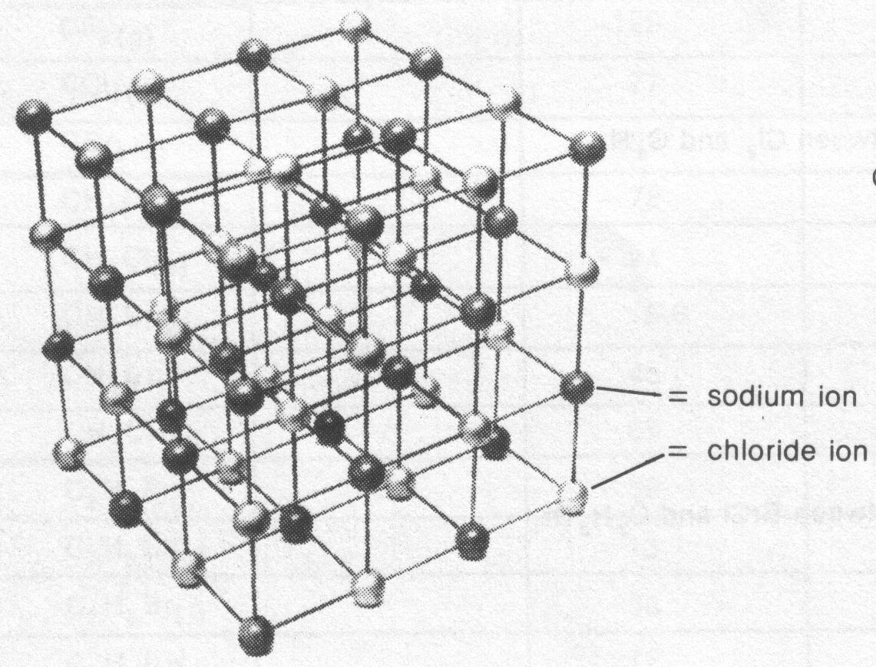Ions in ionic compounds are held together by simultaneous electrostatic forces of attraction among oppositely charged ions. Ionic bonding produces an orderly three dimensional arrangement called a **crystal lattice**. The crystal lattice formed by sodium chloride is illustrated in the diagram to the right. Note that in the NaCl crystal lattice every ion is closest to, and simultaneously attracted by, six ions of opposite charge. Each Na+ ion is simultaneously attracted to six Cl− ions, and each Cl− ion is simultaneously attracted to six Na+ ions.

Although ionic compounds have many similar properties, they do not necessarily have the same shapes. The shape of a crystal reflects how the atoms that make up the crystal are arranged. Sodium chloride crystals are cubic in shape which reflects how the sodium and chloride ions are arranged. Different ionic compounds have different crystal shapes.

# Melting points of ionic compounds

Ionic compounds do not exist as individual molecules. Therefore there are no intermolecular forces (London dispersion or dipole-dipole) involved in ionic compounds. Because the forces which hold ionic crystals together are not concentrated between the individual atoms, **the bonding force involves all of the ions**. In the sodium chloride lattice illustrated above, for example, each sodium ion is surrounded and held in position by six chloride ions. This gives ionic compounds the general property of high melting and boiling points so that they are generally found as solids at room temperature.

For an extended discussion of other types of bonding, i.e. metallic bonding and network covalent bonding, see pages 119 to 130 in the Nelson Chemistry text.

# Ionic bonds – oxidation and reduction

As stated above, metals tend to lose electrons to become cations, while non-metals tend to gain electrons to become anions. Note that a **loss** of electrons results in a **more positive** charge, while a **gain** of electrons results in a **less positive** charge. (For many Chemistry 20 students this sounds counterintuitive – how can a “loss” of electrons result in a “gain” in charge? Remember that removing negative charges is like subtracting a negative number, i.e. −(−1) = +1.) In chemistry we call a gain in charge **oxidation** and a loss of charge **reduction**. Therefore, the loss of electrons results in oxidation, while the gain of electrons results in reduction.

We represent oxidation and reduction using **half-reaction** equations. Using sodium and chlorine as examples, sodium atoms oxidize to become sodium ions by losing an electron.

 (oxidation half-reaction)

Chlorine atoms are reduced into chloride ions by accepting or gaining electrons.

 (reduction half-reaction)

A fundamental part of understanding oxidation and reduction is to realize that **oxidation and reduction always occur together**. A metal cannot oxidize itself by throwing its valence electrons away. There must be something, either a non-metal or a complex ion, available that will accept the electrons that the metal has to offer. Thus in the formation of ionic compounds, one atom is undergoing oxidation while another is undergoing reduction. In the reaction between sodium and chlorine, for example, sodium is oxidized into sodium ions while chlorine is reduced into chloride ions. To represent the formation of sodium chloride we add the oxidation and reduction half-reactions together.

Note that we have to multiply the sodium oxidation half-reaction by 2 in order to balance the number of electrons lost by sodium with the number of electrons gained by chlorine.





When we add the half-reactions together we get:



The electrons cancel out and the ions combine to form the ionic compound.



Write the oxidation and reduction half-reactions and the complete formation equation for strontium phosphide.

Note that we have to multiply the strontium half-reaction by 6 to balance the electrons lost by strontium with those gained by phosphorous.

 (oxidation)

+  (reduction)

________________________



Write the oxidation and reduction half-reactions and the complete formation equation when chromium reacts with oxygen.

We have to multiply the chromium oxidation half-reaction by 4 and the oxygen reduction by 3 to balance the electrons.

 (oxidation)

+  (reduction)

________________________



We will study oxidation-reduction processes in far greater detail in Chemistry 30.

# Assignment

For questions 1 through 3 assume a metallic element M with two valence electrons chemically reacts with a non-metallic element X with seven valence electrons.

1. What kind of bond is most likely to form between M and X?

2. The resulting compound between M and X would form what characteristic kind of solid?

3. Using Lewis diagrams show the electron rearrangement that occurs to form a chemical bond between M and X.

4. Describe the difference between a polar covalent bond and an ionic bond.

5. Discuss the statement, "An ionic bond results from the transfer of electrons".

Classify the bonds in the following compounds as predominately covalent or predominately ionic using both the “staircase” line on the periodic table as the dividing line for classification and their difference in electronegativities.

6. KCI 9. HI

7. LiBr 10. CH4

8. CaS 11. H2S

Identify the bond types (ionic, non-polar covalent or polar covalent) for each of the following substances.

12. BrCl 16. CCl4

13. P4 17. FeCl3

14. CsF 18. K2S

15. CO2 19. SiF4

20. Discuss the idea that **all** bonding can be described in terms of simultaneous attractions.

21. Explain why oxidation and reduction always occur at the same time.

22. For the following questions, write the oxidation and reduction half-reactions and the complete equation.

A. Al + F2  →

B. Li + Cl2  →

C. Fe + O2  →

D. Mn + N2  →

E. Cu + S8  →

F. Mg + As →

G. W + Se →